Gary Milne

Tasmota Sync Sensor Drivers

A guide for installation and use – Aug 24th, 2022

Contents

TLDR 2

Intro 2

Architecture 2

Drivers 3

Installing a New Device 3

Driver Installation 3

Device Installation 3

Common Settings 4

Configuring the device 4

tasmotaInjectRule 5

TelePeriod 6

Tasmota Sync 6

Add\Change Sensor on an existing Hubitat Device. 6

Advanced Topics 7

SensorSwitches 7

Limitations 8

Rules and Triggers 8

Shrinking the CustomAttribute List 9

Tasmota Sync – Device Drivers for Hubitat

Automatic Synchronization between Tasmota and Hubitat without custom Tasmota

# TLDR

These drivers allow Hubitat to synchronize with Tasmota (11 onwards) without the need for any special Tasmota compilation or use of HTTP hooks. A rule installed onto Tasmota by the Hubitat driver causes Tasmota to send a synchronization request whenever a monitored setting changes. Changes made on Tasmota will be reflected on Hubitat within 1-2 seconds. No polling or custom Tasmota build required. Interested? Read on.

# Intro

The original Tasmota Sync docs cover the installation and configuration of the Tasmota Sync device drivers. This supplement covers the use of Tasmota Sync sensor drivers which I thought would benefit from separate coverage because it is a more complex and nuanced environment. For an intro to the Tasmota Sync drivers and basic installation read the other doc first and then come back to this one.

# Architecture

Quite simply the Hubitat Sensor driver for a given Tasmota device injects a rule into Tasmota that causes Tasmota to report any changes to the parameters of interest. Below is an example of a rule that monitors a Tasmota device with a T&H sensor plus a relay. You don’t need to understand it, just know it is required for Tasmota Sync to work. Each type of Tasmota device has a unique rule that is managed by the driver.

|  |
| --- |
| ON Power1#state DO backlog var8 %value% ; RuleTimer1 1 ENDON  ON Tele-SI7021#temperature DO backlog0 var9 %value% ; RuleTimer1 1 ENDON  ON Tele-SI7021#humidity DO backlog0 var10 %value% ; RuleTimer1 1 ENDON  ON Rules#Timer=1 DO var15 '%var8%','%var9%','%var10%','%var11%' ENDON  ON var15#State$!%var16% DO backlog ; var16 %var15% ;  webquery http://192.168.0.200:39501/ POST {'TSync':'True','Switch':'%var8%','temperature':'%var9%','humidity':'%var10%'} ENDON |

# Drivers

There are 3 completed drivers in the Tasmota Sync MultiSensor family. All of which are built on the same core driver.

1. Universal Multi Sensor Driver
2. Universal Multi Sensor Driver with Single Relay
3. Universal Multi Sensor Driver with Dual Relay

The Tasmota Sync family drivers are located here: <https://github.com/GaryMilne/Hubitat-Tasmota> The Tasmota Sync drivers all share a lot of core functions and are internally consistent for easier code maintenance.

# Installing a New Device

This section gives a detailed example of how-to setup a new device. In this example I am using a WeMo D1 Mini with multiple sensors, but the same principles are true for all devices.

## Driver Installation

The Tasmota Sync Sensor drivers install like any other Hubitat driver. In this case I will use the Universal Multi Sensor Driver with Single Relay, but the same steps are true for any of the sensor drivers.

* Go to your “Drivers Code” page and click on “New Driver”.
* Click on “Import”.
* Paste this URL into the field: **https://github.com/GaryMilne/Hubitat-Tasmota/blob/main/Universal_Multi_Sensor_Single_Relay.groovy**
* Click “Save”.

The driver should now be installed and be listed in your drivers list as “Tasmota Sync – Universal Multi Sensor with Single Relay”.

## Device Installation

Now you are ready to add the device to Hubitat. For this step you will need to know the IP addresses of the Tasmota Device and the Hubitat Hub.

* Go to your “Devices” page.
* Click on “Add Device”
* Click on “Virtual”
* Enter a device name and a device label
* For Type*, select Tasmota Sync – Color Bulb which will be down near the bottom of the list in the **User** category.
* Make any other changes that you wish and click “Save Device”.

You will be taken to the device properties page. Scroll down to the “Preferences” section which will looks like this. Actual appearance will vary if a difference number of relays are present.

You must complete the Tasmota Device IP Address and Hubitat Hub IP Address fields. All others are optional.

## Common Settings

See the basic “Tasmota Sync Documentation.pdf” for descriptions of these settings.

## Configuring the device

Click on “**Initialize**”. If things are configured correctly the “**Current States**” area will populate with the appropriate attributes. If the “**Status**” does not show “Complete: Success” then there is some connectivity issue. Check your device IP address and whether any credentials are required.

Once you have received data do a refresh of your browser to refresh the “State Variables” area.

Have a closer look at the “**sensorData**” field. In the above example it looks like this:

|  |
| --- |
| **[BME280:DEWPOINT:14.0:dewPoint, BME280:HUMIDITY:54.0:humidity, BME280:PRESSURE:982.7:pressure, BME280:TEMPERATURE:23.9:temperature, DS18B20-1:TEMPERATURE:25.4:temperature1, DS18B20-2:TEMPERATURE:25.3:temperature2, DS18B20-3:TEMPERATURE:25.0:temperature3, SWITCH3:SENSOR-SWITCH:off:switch3]** |

This is a comma separated list of sensors\switches and associated parameters. It reads like this; SensorName:AttributeType:AttributeValue:hubitatMappedAttribute, next record etc.

Each of the sensors shown on your Tasmota screen should be listed plus any relays or switches that are attached.

Note the presence of “**SWITCH3:SENSOR-SWITCH:off:switch3” in the sensorData that is not shown here. This is a PIR sensor and we will discuss sensor switches later.**

If you sensorData is populated correctly you can proceed to the next step.

## tasmotaInjectRule

tasmotaInjectRule creates a rule based upon the detected sensors, attributes and switches and injects it into Tasmota Rule3. The result is that Tasmota will send changes to Hubitat without the need for any polling. Changes in the state of switches will get sent immediately (typically 1-2 seconds). Changes in the value of sensor data will get sent at the interval defined by the TelePeriod (10-3,600) seconds. To check that the rule is installed on Tasmota you can type “rule3” at the Tasmota console. Note: You can disable rule3 by typing “rule3 off”. You can delete rule3 by typing ‘rule3 “” ‘ .

## TelePeriod

TelePeriod, short for Telemetry Period, can be configured anywhere in the range of 10 – 3,600 seconds (1 hour). You can use the TelePeriod button in the driver to quickly change this. Change this to 10 seconds for testing out the device.

## Tasmota Sync

You now should have everything in place and you should be receiving data at the TelePeriod interval. Have a look in the Hubitat logs, you should see TSYNC activity.



Note: Data will only get sent at the TelePeriod if **at least one monitored item has changed** in value. If nothing has changed at the TelePeriod interval no data will be sent.

Everything should now be working and you can set the TelePeriod to a more appropriate value.

## Add\Change Sensor on an existing Hubitat Device.

To force Hubitat to re-discover the attached sensors do the following:

1. Click “Clear Attributes”
2. Perform a browser refresh.
3. Click “Initialize” and wait for the attributes to populate.
4. Perform a browser refresh and check the discovered sensors\switches look correct.
5. Click “tasmotaInjectRule”
6. Set TelePeriod to 10 and verify changes occurring on the Tasmota device are getting transferred to Hubitat. Check the logs if necessary.
7. Once all is good reset the TelePeriod to the desired value.

# Advanced Topics

## SensorSwitches

In the Universal Multi Sensor Driver switch1 and switch2 are designated for relays. This is the normal type of switch that you would use to turn an attached device off and on.

However, Tasmota treats other devices as switches also. Devices such as PIR sensors, water leak sensors, proximity sensors act as simple switches. These are not displayed on the Tasmota UI and can only be accessed via the Tasmota console using the “Status 10” command which looks like “STATUS10 = {"StatusSNS":{"Time":"2022-08-23T17:49:32","Switch3":"OFF","DS18B20-1":{"Id":"3C01F0965038",……………………” Notice the presence of the “Switch3”:”OFF”.

To facilitate the use of these types of devices I have designated Switch3 and Switch4 for use with these types of devices. Anything connected as switches 5 – 8 will be ignored.

To make sure that your sensor switch device is reporting correctly **you must configure it to use Switch3 or Switch4** in the Tasmota configuration as shown below.

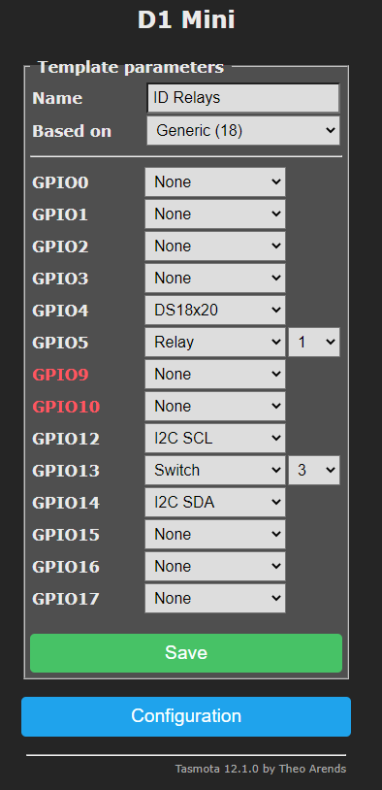

## Limitations

Rule3 uses Tasmota variables to hold and compare values to determine whether changes have occurred and need to be sent to Hubitat. In above example it creates a composite value of Var15="0,14.5,56.5,982.2,23.7,26.1,25.9". See how it relates to the values in the TSYNC data below.

{"TSYNC":"TRUE","SWITCH1":"","DEWPOINT":"14.5","HUMIDITY":"56.5","PRESSURE":"982.2","TEMPERATURE":"23.7","TEMPERATURE1":"26.1","TEMPERATURE2":"25.9","TEMPERATURE3":"25.6","SWITCH3":"2"}

But notice that the last entry in the Var15 is 25.9 which corresponds to TEMPERATURE2. What happened to the values for TEMPERATURE3 and SWITCH3. Well, Tasmota has a 32 character limit for a single variable and with 7 sensor values plus 2 switches we have exceeded this.

I don’t think it’s a big issue as I don’t expect many people will have as many sensors on a single device. If you need to create more space you can do one of two things. A) Change the resolution of one or more attributes to shrink the amount of data. For example “TempRes 0” would eliminate the decimal point and any subsequent characters. B) Change the code and remove the “,” between the values as these only contribute to readability, not function.

## Rules and Triggers

The default created Rule3 and associated triggers should be sufficient for most people but for those interested in more unique situations it is possible to customize the existing Rule3 or add another rule all together.

From the Tasmota documentation.

<https://tasmota.github.io/docs/Rules/#rule-syntax>

For example, the following rule would send immediate TSYNC data whenever the temperature of the BME280 sensor goes above 85 degrees.

|  |
| --- |
| rule2 ON BME280#temperature > 85 DO backlog0 var9 %value% ; webquery http://192.168.0.201:39501/ POST {'TSync':'True','temperature':'%var9%'} ENDON  rule2 ON |

Notice that you only need to specify the ‘TSync’:’True’ and the name of the Hubitat attribute (temperature) that you want to map this data to.

## Shrinking the CustomAttribute List

By default, the driver has all attributes and capabilities enabled. The resulting number of custom attributes is quite large as indicated in the graphic on the left. When reduced to better match a particular type of sensor (Environmental in this case) the list of custom attributes shrinks and is much more relevant as shown on the right.

|  |  |
| --- | --- |
| **All Attributes**   | **Only Common Attributes** |

To do this look for a piece of code in the driver that looks like this.

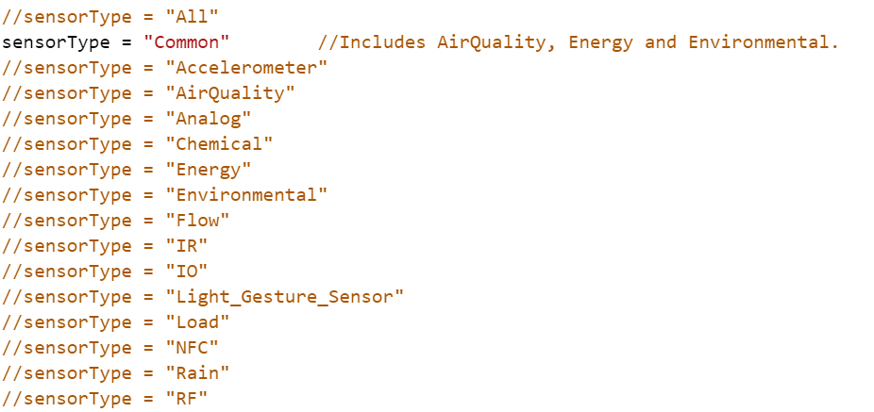

Comment out the sensorType = “All” and remove the comments from the section that you want. Remember that this is a shared driver on your system. This change will apply to all devices running this driver unless you make a copy and rename it to something else.